Eoin Lynch

DT211c  C16310846

Build A pc Final Report

**Table of Contents**

Section 1: Introduction …………………………………………………………………….. Pg 0

Section 2: Description ………………………………………………………………………. Pg 3

Section 3: Assembly …………………………………………………………………………. Pg 6

Section 4: Operating Systems …………………………………………………………… Pg 9

Appendix A: Bill of PC Components ………………………………………………….. Pg 10

Appendix B: Energy Consumption of a PC ………………………………………… Pg 12

Appendix C: Electrostatic Discharge …………………………………………………. Pg 13

Appendix D: Sketch of PC …………………………………………………………………. Pg 14

References ……………………………………………………………………………………….. Pg 15

**Section 1: Introduction**

This report details the work that has been done in the Building a PC module. In this section, the introduction, I will be discussing what this report contains and I will also provide a brief history of computing. In section two, the document’s main description, I will describe the main components of the computer that was built, their role in running the PC and how they work and interact with the PC. In section three, the section about Assembly, I will be talking about how each part of the computer was installed and I will give a list of steps that were used in building the PC. In the last section, section four, I will be talking about how we installed both Windows 7 and Linux Ubuntu in dual boot mode. I will then include four appendices. Appendix A; PC’s Bill of Materials, Appendix B; Energy Consumption of a PC, Appendix C; Electrostatic Discharge and Appendix D will provide a Sketch of the PC.

I will now provide a brief history of computing. The history of computing can be divided into five stages or generations. These stages represent significant milestones in the development of computers.

The first generation of computing spans from 1942 – 1955. Examples of first generation computers are ENIVAC and UNIVAC. In this generation, computers relied heavily on vacuum tubes as these were the only electronic components that were developed at the time. This was a great development in the evolution of computing as the development of vacuum tubes advanced the evolution of computers and sparked interest in computing and promoted investment. However, the use of vacuum tubes also carried a lot of disadvantages. Such disadvantages were that these computers were very large and thus required a lot of maintenance, the computers heated up quickly as they used a lot of energy and these early computers were very expensive to produce and run. These early computers relied on punch cards for input and did not have many programming capabilities.

The second generation of computers were developed between 1955 – 1964. These second generation computers used transistors. The first transistors were developed at Bell laboratories in 1947 by scientists such as William Brattain and William Shockley. The use of transistors eventually came to take over the use of vacuum tubes and thus the size of computers decreased. These computers were more reliable than the first generation computers and used way less energy than the first generation computers. These computers used faster components such as tape drives and magnetic disks whereas the first generation of computers mainly used magnetic drums for storage which were not efficient. These computers also used assembly language instead of machine language which advanced their programming capabilities. All these benefits furthered their commercial potential and more companies started to use these computers. However, cooling systems and maintenance were still required and punch cards were still used as input for these second-generation computers.

The difference in second-generation computers and third-generation computers is very dramatic. These third-generation computers used integrated circuits and were developed between 1964 – 1975. The concept of an integrated circuit was developed in 1958 by Jack Kilby and the first integrated circuit was used in 1961. These integrated circuits were

extremely efficient as they contained thousands of transistors. This allowed computers to become smaller, faster, and less expensive than computers had ever been before. These computers did not need constant maintenance as the hardware rarely failed and they also produced less heat than the previous generations. These computers started the use of computers for commercial production. This generation of computers also furthered the use of computers for programming as these computers could use high level languages unlike the previous generation’s computers. This generation of computers also started the use of keyboard and mouse for input unlike the previous generations where punch cards were used for input. The only real disadvantages for these computers were that they still required air conditioning and needed sophisticated technology for the manufacturing of these chips.

The drastic differences between these generations of computers continued with the fourth generation of computers. The use of fourth generation computers stretches from 1975 to the present day. Unlike the third generation of computers where only a few integrated circuits were used the fourth generation of computers used thousands of integrated circuits. These thousands of integrated circuits were found in microprocessors which were manufactured in 1971 for Intel by Ted Hoff. In this generation of computers Large Scale Integration circuits and Very Large Scale Integration circuits were designed. This led to computers being extremely portable and allowed computers to fit on a desk instead of the earlier generations of computers which would often have an entire room dedicated to a single computer. The microprocessors that were used in these computers usually contained millions of circuits. An example of these fourth-generation computers is the Apple Macintosh. These fourth-generation computers are the cheapest of the previous generations and thus lead to mass commercial production of computers. These fourth-generation computers are also very good for programmers as all sorts of high level languages can be used in this generation of computers. The only real disadvantage to the use of these fourth-generation computers is that the newest technology is required to manufacture microprocessors.

Fifth generation computers are only recently beginning to be developed. Fifth generational computers are based on Artificial Intelligence, or AI. These fifth generational computers are being developed to understand spoken words and imitate human morality and reasoning. Scientists are attempting to create a computer with an IQ by using advanced programming technologies. An example of a fifth generational computer is the IBM Watson which has outsmarted Harvard University Students. These fifth-generation computers are the future for computers.

**Section 2: Description**

In this section I will provide a brief description of the components of a computer such as the microprocessor, motherboard, memory, hard disk, power supply, fans and cooling, LCD Display and the keyboard and mouse.

**Microprocessor**

The microprocessor is often referred to as the brains of a computer. The microprocessor contains the central processor unit, or CPU, functions. Microprocessors are designed to perform arithmetic and logic operations using registers. Examples of functions that a microprocessor preforms are adding and subtracting numbers. The microprocessor completes these functions because of instructions that are given to it by the computer, the first instruction of which comes from the BIOS. The leading producers of microprocessors for PCs are Intel and AMD. Below are images of the CPU that we used for our PC. The picture on the left shows what a CPU looks like from above and the second image shows what a CPU looks like with it’s pins exposed.

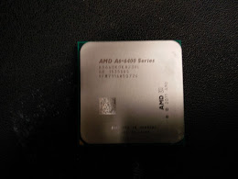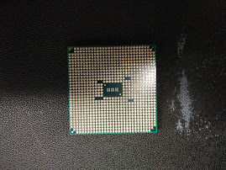

**Motherboard**

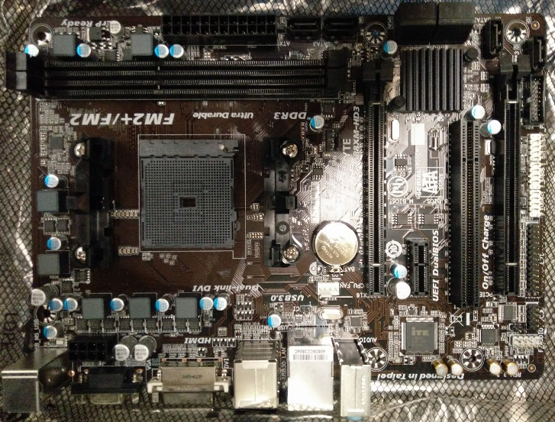A motherboard is a piece of hardware in a computer that contains it's circuits and components. Most motherboards have their circuitry imprinted on them during the manufacturing process. The most design of motherboards in computers is the AT which is based on IBM's AT motherboard. More recent iterations of the AT motherboard are the ATX and microATX motherboards. The below images show the motherboard which was used in the building of my PC.

**Memory**

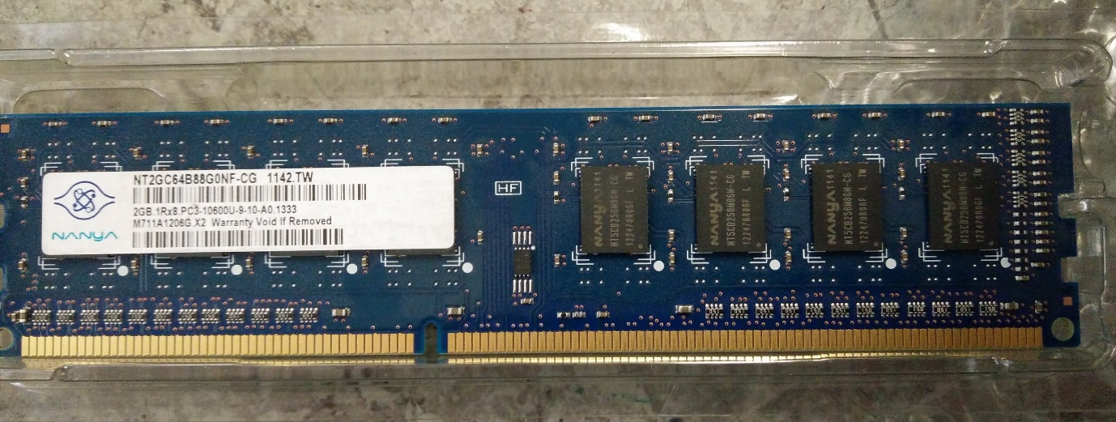Memory can come in two forms, either persistent memory or transient memory. Persistent memory is mainly stored in hard drives whereas transient memory is often stored in random access memory, or RAM. I will now be talking about RAM. Ram is a form of transient data which means it stores data temporarily. Data on ram is stored until it is cleared from memory or until the data is saved to persistent memory. Ram is made of silicone with strands which are used to allow electricity and data to flow. A stick of RAM contains millions of miniature switches called transistors. These transistors are used to control bursts of electricity, each burst contains a bit. Below are some images taken of the RAM used in my PC.

**Hard Disk**

A hard disk is a persistent storage device. It is often also referred to as a hard drive or a hard disk. A hard disk drive contains a set of stacked disks that use electromagnetism to store data on the disks. A head writes data to the disks in tracks on the disks. There are two heads on each side of the disks which are used to read from and write to the disks. These hard disks often have a rotation speed from around 4500 to 7200 rpm, hard disk drives with a high rotation speeds often have faster read and write than hard disk drives with lower rotation speed. Below is a picture of the hard disk drive that I used in my PC.

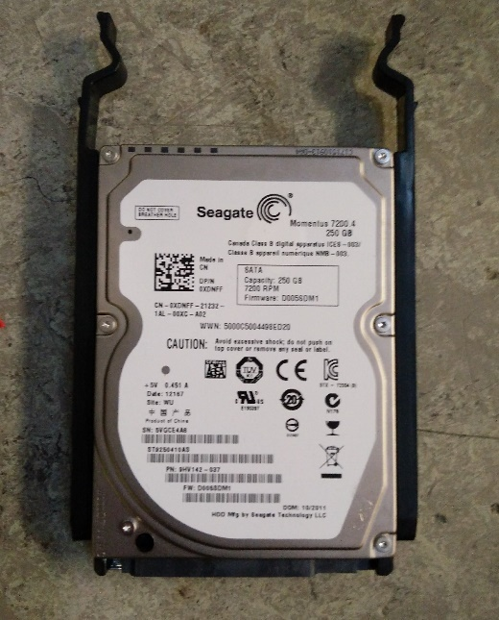

**Power Supply**

A power supply, also known as a PSU, converts power provided from an outlet or socket into power that’s usable to the parts inside a computer. Power supplies covert alternating current, or AC, into a direct currency, or DC which allows the computer to run normally. The power supply also regulates overheating in the system by controlling the voltage in the PC. Below is a picture of the power supply that was used in my PC.

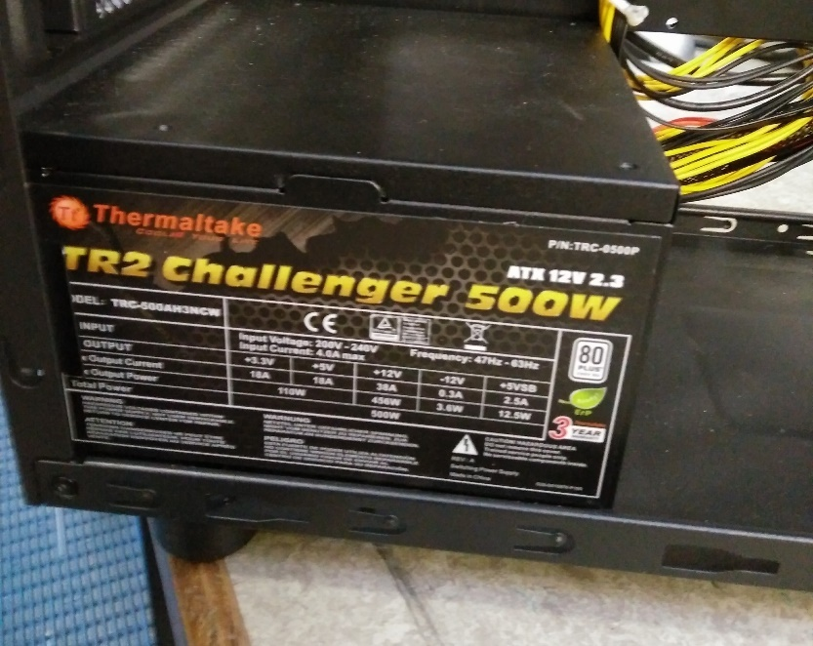

**Fans and Cooling**

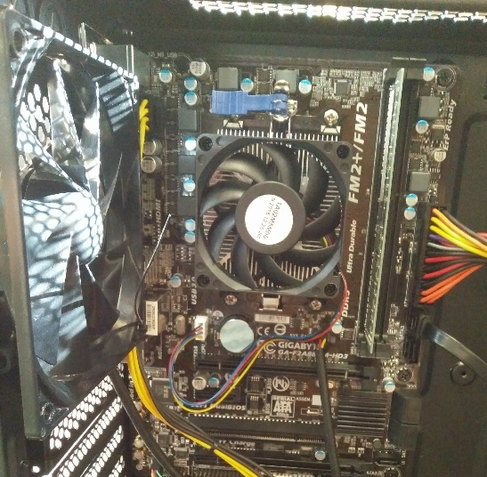Cooling is an integral part of any pc. One of the most important parts of a PC is the heat sink that’s located on the CPU. This is used to stop the CPU from overheating. The fan on the heatsink is controlled by the PC so it can compensate for any extra heat that may be produced from a heavy load or overclocking. Fans are also typically mounted all around the PC case to cool down the PC and there is also an exhaust fan to push heat out of the PC case. Below is a picture showing my PC’s heatsink and exhaust fan.

**LCD Display**

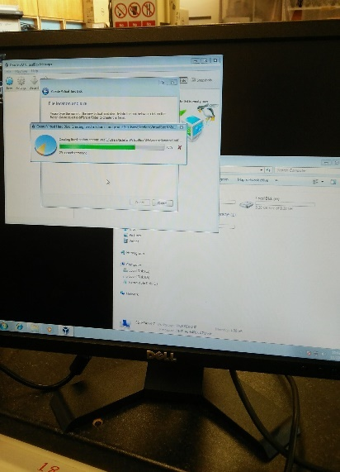LCD displays are a mode of output for the PC. LCD stands for liquid crystal display. These displays are extremely efficient as they focus on blocking light whereas plasma displays work by emitting light. These displays work by sending a current across two conductors on the grid to control each pixel that is being used. These displays also have a high refresh rate. Below is an image of an LCD display that was used for my PC.

**Keyboard and Mouse**

The keyboard and mouse are the most common forms of input on a PC. A keyboard allows a user to type letters, numbers, and other symbols on a computer. Keyboards work and send information to the microprocessor when a key is pressed down, this is because when a key is pressed it completes a circuit and this information is then sent to the microprocessor. A mouse is used to control a pointer on a screen. An optical mouse does this by quickly taking 100’s of images a second to notice any differences between the images, if there is a difference the pointer moves. Below is an example of a keyboard and mouse.

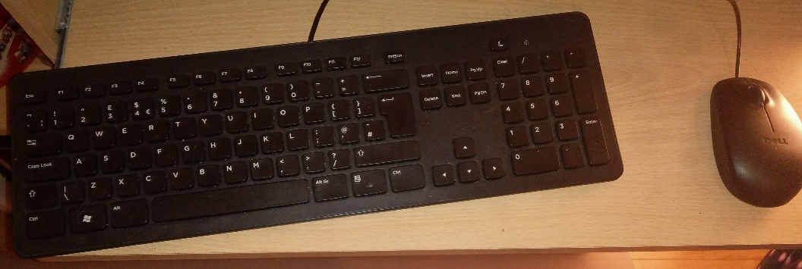

**Section 3: Assembly**

I will now detail the steps I took to build my computer. Before I built my computer, I needed antistatic matt, antistatic wristband, screwdriver and all the components.

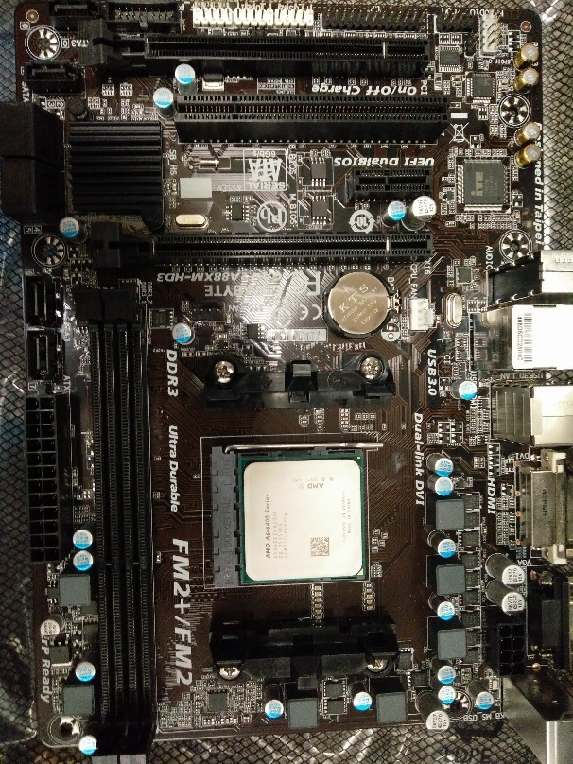**Step 1:** First I took out the motherboard and placed it on the antistatic bag provided. Then I matched the triangle in the corner of my CPU with the corner in the CPU socket in my motherboard and place the processor in the socket.

**Step 2:** I placed some thermal paste on the processor about the size of a pea and spread it using a spatula. I then cleaned the thermal paste already installed on the heat sink with alcohol wipes to make sure it was 100% clean. I then lined up all the hooks and placed the heat sink on the processor gently and then clamped it into place.

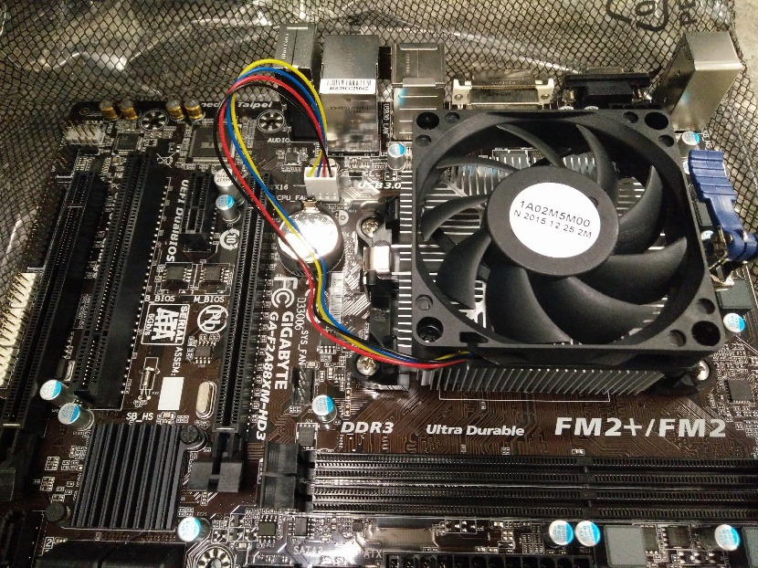

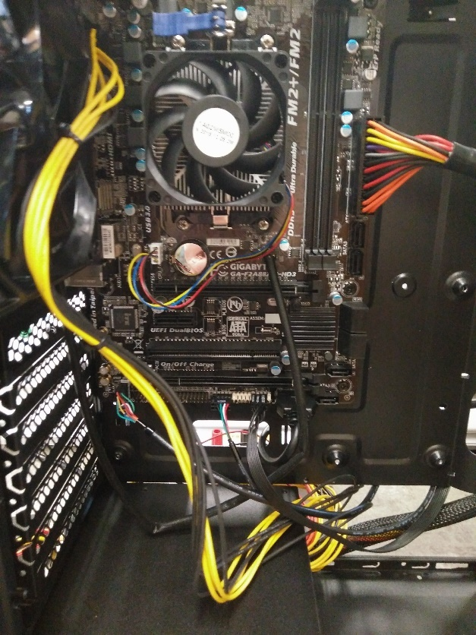**Step 3:** Attach the I/O shield to the back of the case that is supplied with the motherboard. I then screw in the standoff screws into the case to provide lift from the case, this also stops the case from shorting the motherboard. Place the motherboard into the case carefully and screw it in gently.

**Step 4:** I inserted the power supply into the computer case and screwed it into place. I then carefully placed the ram into the motherboard and made sure that the clips were fastened securely. Once I did this I started to connect the power cables to the motherboard.

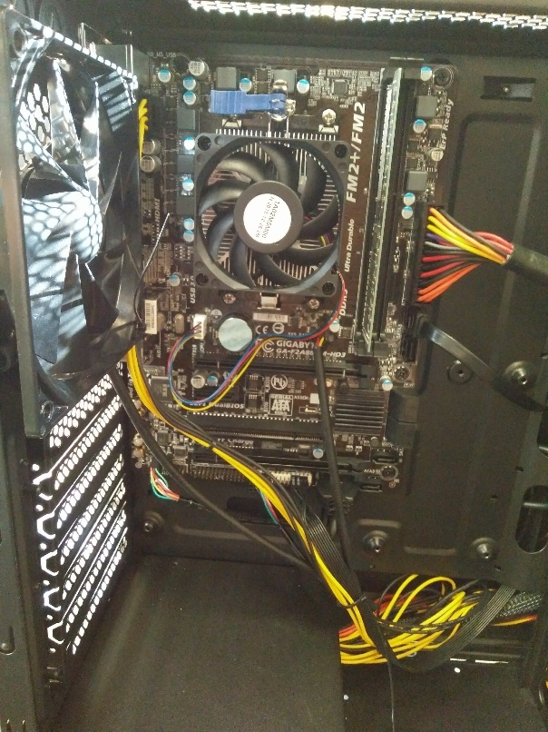

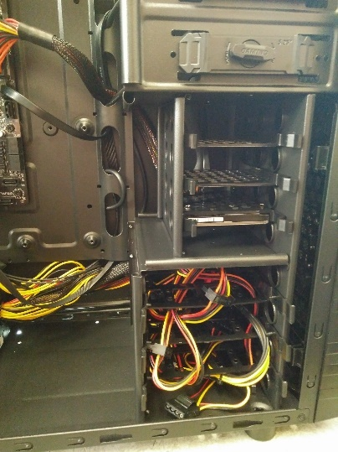**Step 5:** I then attached the bracket to the HDD and placed it in the cage for storage drives. Once I did this, I then connected it to power and then connected a SATA cable between the hard drive and the motherboard.

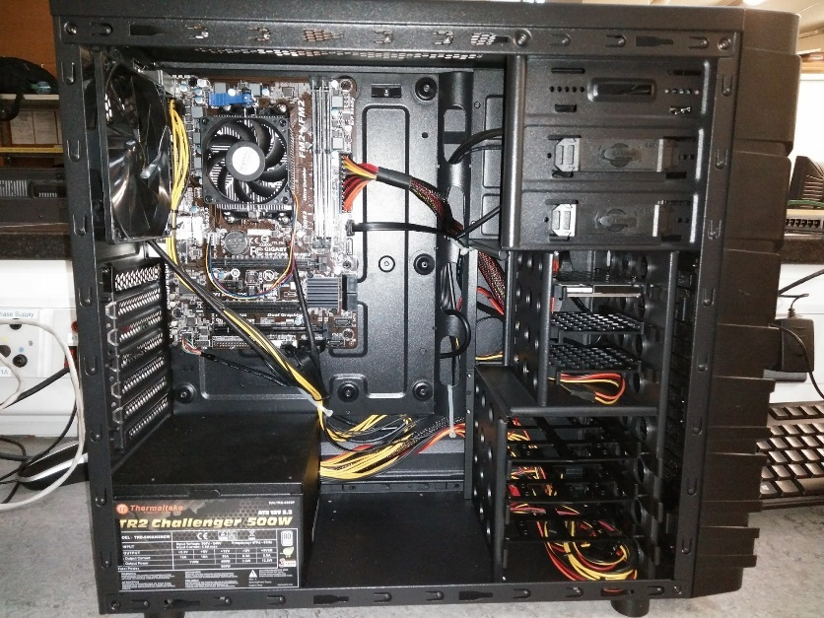**Step 6:** I then made sure all the front ports were connected to the motherboard and that all power and data cables were working correctly. Then I tidied up my cables to allow for a good airflow.

**Step 7:** I then booted my computer to check that all LEDs were working on the front of the case and that all ports were working correctly. I then continued to install windows.

**Section 4: Operating Systems**

I will now give the details of how I installed both Windows 7 and Linux Ubuntu on my computer in a dual boot configuration.

**Windows 7 Installation:**

1. Plug the USB drive containing Windows 7 installation files into your PC and boot it up. Enter BIOS and change the boot option from the hard drive to the USB drive.
2. Once the computer boots up go through all the installation options such as language and time zone until you get to where you want to install Windows 7.
3. Delete all current partitions on the hard drive until you have just one amount of unused storage.
4. Create a partition of 125 gigabytes for Windows 7 to be installed on and leave the other partition blank for the installation of Linux Ubuntu later.
5. Install Windows 7 on the first partition.

**Linux Ubuntu Installation:**

1. Boot up your PC and enter BIOS.
2. Change boot options from the hard drive to the USB drive.
3. Go through all the installation options such as selecting language and time zone.
4. Once I got to the partition stage I set up the following partitions on my PC.

|  |  |  |  |  |
| --- | --- | --- | --- | --- |
| Partition | Mount Point | Size | File System | Type |
| root | / | 30 gb | ext4 | primary |
| home | /home | the rest | ext4 |  |
| shared | /windows | 10 gb | fat32 |  |
| swap space |  | 8 gb | swap |  |

1. Once I set up the partitions and installed Linux Ubuntu I used the following commands to install programs and complete actions in the Linux command prompt:

* sudo apt_get update – This command updates a select package.
* apt-get upgrade – This installs important updates to Linux.
* sudo nano – This command opens the text editor in the command prompt.
* apt-cache search – This command searches for and displays which software packages are available to download.
* cd – This command changes the current active directory.
* mkdir – This command creates a directory.

**Appendix A: PC Bill of Materials**

I will be setting up a mid-range gaming computer. The reason I will be setting up this computer is that it is often assumed that to get a PC that is good for gaming you must spend a lot of money. This is not true; my gaming computer will cost between €600 and €800. I used amazon.co.uk to source all my components as it is a cheap website to use and components can be shipped to Ireland either directly or by Parcel Motel. This computer’s goal is that it will be able to comfortably play most new video games and achieve 45-60 frames per second on medium to high settings.

The first item I looked at when looking for components for my gaming PC was a CPU. I chose an Intel core i5 4460 quad-core CPU clocked at 3.2 ghz. I chose this CPU as quad core CPU’s can handle processor heavy video games. One of the sacrifices I made to keep the processor within my budget was that it is a previous generation processor and this processor cannot be overclocked. However, for the price of £169.99 on Amazon, which translates to €191.34, it is good value for money.

I wanted to create a PC with a small form factor so I needed a micro ATX motherboard and a micro ATX case. I decided to pick the Gigabyte GA-H81M-D2V motherboard and the Aerocool QC-203 case. This case supports micro ATX motherboards and has USB 2.0 and 3.0 ports. The motherboard I have chosen supports the LGA1150 socket that is found on the i5 4460. It also has 2 DDR3 slots for RAM and has a PCIE 2.0 slot for a graphics card. This motherboard gets the job done well for the price of £59.99 or €67.53 on Amazon and the case is good quality for the price of £22.99 or €25.88 on Amazon.

I then needed to source RAM and a graphics card. I decided to get a single stick of 8gb of DDR3 RAM. I decided to choose the HyperX FURY Series 8 GB DDR3 RAM clocked at 1600 MHz. I chose this RAM as it’s fast and having 1 stick of 8 gb of RAM on a motherboard with just 2 sockets for RAM allows you to double the amount of RAM you have if you choose. For £39.99 or €43.86 for a stick of 8gb of ram on Amazon this is great value.

Having a good graphics card is an integral part of any gaming PC. However, to keep our costs low I will be using a mid-range graphics card. The graphics card I will be using is the MSI NVIDIA GTX 750Ti 2GB card. This graphics card preforms well in new video games as it achieves 30 to 40 frames per second on ultra in most graphically intensive games and can easily achieve 50+ frames per second on medium to high settings on most new releases.

For storage, I decided to choose both a solid-state drive and a hard disk drive for my PC. I did this because many gamers often complain about long loading times in their video games and one of the causes of this problem is with their hard drive speeds, an SSD can dramatically increase loading times in many video games. I decided to pick an ADATA Premier SP550 120GB SSD as this gives a gamer enough space for a few of their favourite games. I then chose the WD Caviar Blue 500GB HDD to hold the operating system and any other games or files. These two components are very good value for money as the SSD costs £39.64 or €44.62 on Amazon and the HDD costs £37.75 or €63.01 on Amazon.

**Appendix A: PC Bill of Materials**

Finally, I decided to look for the power supply I was going to use. Once I had all my other components I used the power supply calculator on outervision.com to see how much power my PC needed to run. Once I ran the calculation I decided that a 500 watt power supply would meet the requirements of the system. I then picked the Corsair CP-9020047-UK Builder Series power supply. This power supply has enough power for my PC and is well worth the price of £59.99 or €67.42 on Amazon.

These components combined cost a total of €638.74 which is within my cost margin. This gaming PC has good components and is good for a gamer who doesn’t have a lot of money to spend. The cost of this PC does not include the cost of an OS but a copy of Windows 10 can be bought for €135.00.

**Appendix B: Energy Consumption of a PC**

**Table detailing readings from Watt meter for various PC states:**

|  |  |  |
| --- | --- | --- |
| **Component/State of PC** | **Average watts in a minute** | **Average kilowatts in a minute** |
| Monitor | 17.8 | 0.0178 |
| Booting PC | 71.2 | 0.0712 |
| Quiescent PC | 24.5 | 0.0245 |
| Stress Test PC | 82.9 | 0.0829 |

Using these results, I made two calculations:

* I calculated the cost of leaving a PC with a monitor on for a year non-stop. The assumption I made for this calculation was that the PC would only boot once, I also assumed that for 20% of the time it would be operating under maximum load. I then calculated that the cost of leaving this PC on for a year using the measurements above. I calculated that if it costs €0.16 per kilowatts per hour, the cost of leaving this PC on for a year would be €75.72.
* I then calculated the cost of operating a server farm containing 1000 PC’s and 1 monitor. The monitor and PC’s would be left on for a year. The assumptions I made for this calculation were that the 1000 PC’s would only boot once, I also assumed that for 20% of the time the server farm would be operating under maximum load. I calculated the cost of running the server farm for a uear using the measurements above and that it costs €0.16 per kilowatts per hour. The cost of operating a server farm for a year with just 1 monitor and 1000 PC’s came out to be €50,800.29.

**Table detailing range of power consumption in different parts of a PC:**

|  |  |  |
| --- | --- | --- |
| **Components** | **Power Consumption (Watts)** | **Reference** |
| Power Supply | 350 watts 🡪 1000 watts | www.komplett.ie |
| Motherboard | 25 watts 🡪 80 watts | www.buildcomputers.net |
| Processor | 55 watts 🡪 150 watts |
| RAM | 2 watts 🡪 5.5 watts |
| HDD | 0.7 watts 🡪 9 watts |
| SSD | 0.6 watts 🡪 2.8 watts |
| GFX Card | 5 watts 🡪 350 watts |

**Appendix C: Electrostatic Discharge**

Electrostatic Discharge, or ESD, occurs when static energy is released when two objects come into contact. This can often happen when someone touches an object or a person but it can also occur to PC components. ESD is a very expensive problem, especially in industry where ESD can often damage expensive pieces of equipment. ESD requires a build-up of electrostatic charge. This build-up of charge occurs when two objects rub off each other and create friction with each other. One of the objects becomes positively charged whereas the other becomes negatively charged. The positively charged object is now electrostatically charged. When the positively charged, device meets the right object an electrostatic charge is released.

An electrostatic charge generates a lot of heat, this heat can often melt small components in circuits. Small electrostatic shocks can often damage a device but not damage it to the point to where it doesn’t function anymore, this is called a latent defect which can often shorten the lifetime of a component. Nowadays many computer components have become resistant to ESD, however it is often to be safer than sorry. When working on a computer it is often advised that a user would wear an ESD wrist strap to prevent ESD and to also use an ESD mat to make sure that any components that are placed on this mat are not charged and at risk of electrostatic shock.

Below is an image of an ESD wristband and an ESD mat that were used in the building of my PC.

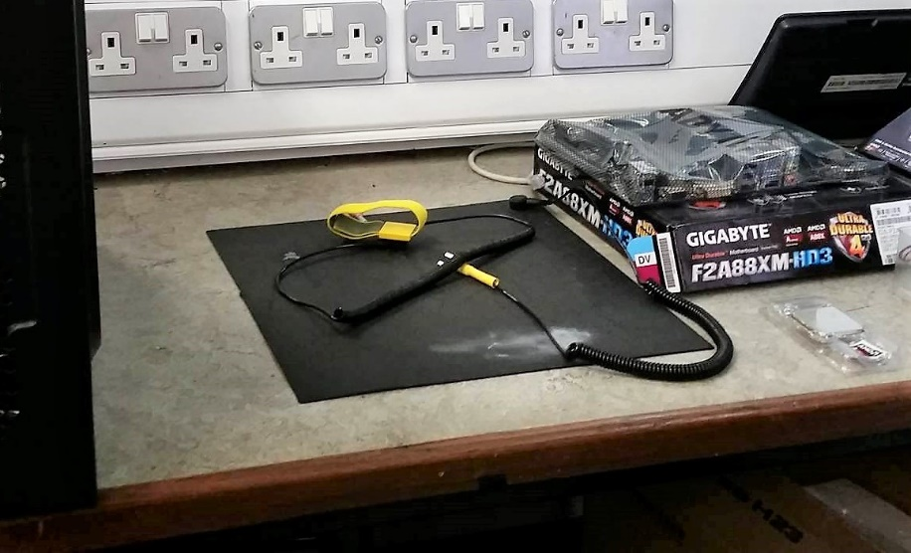

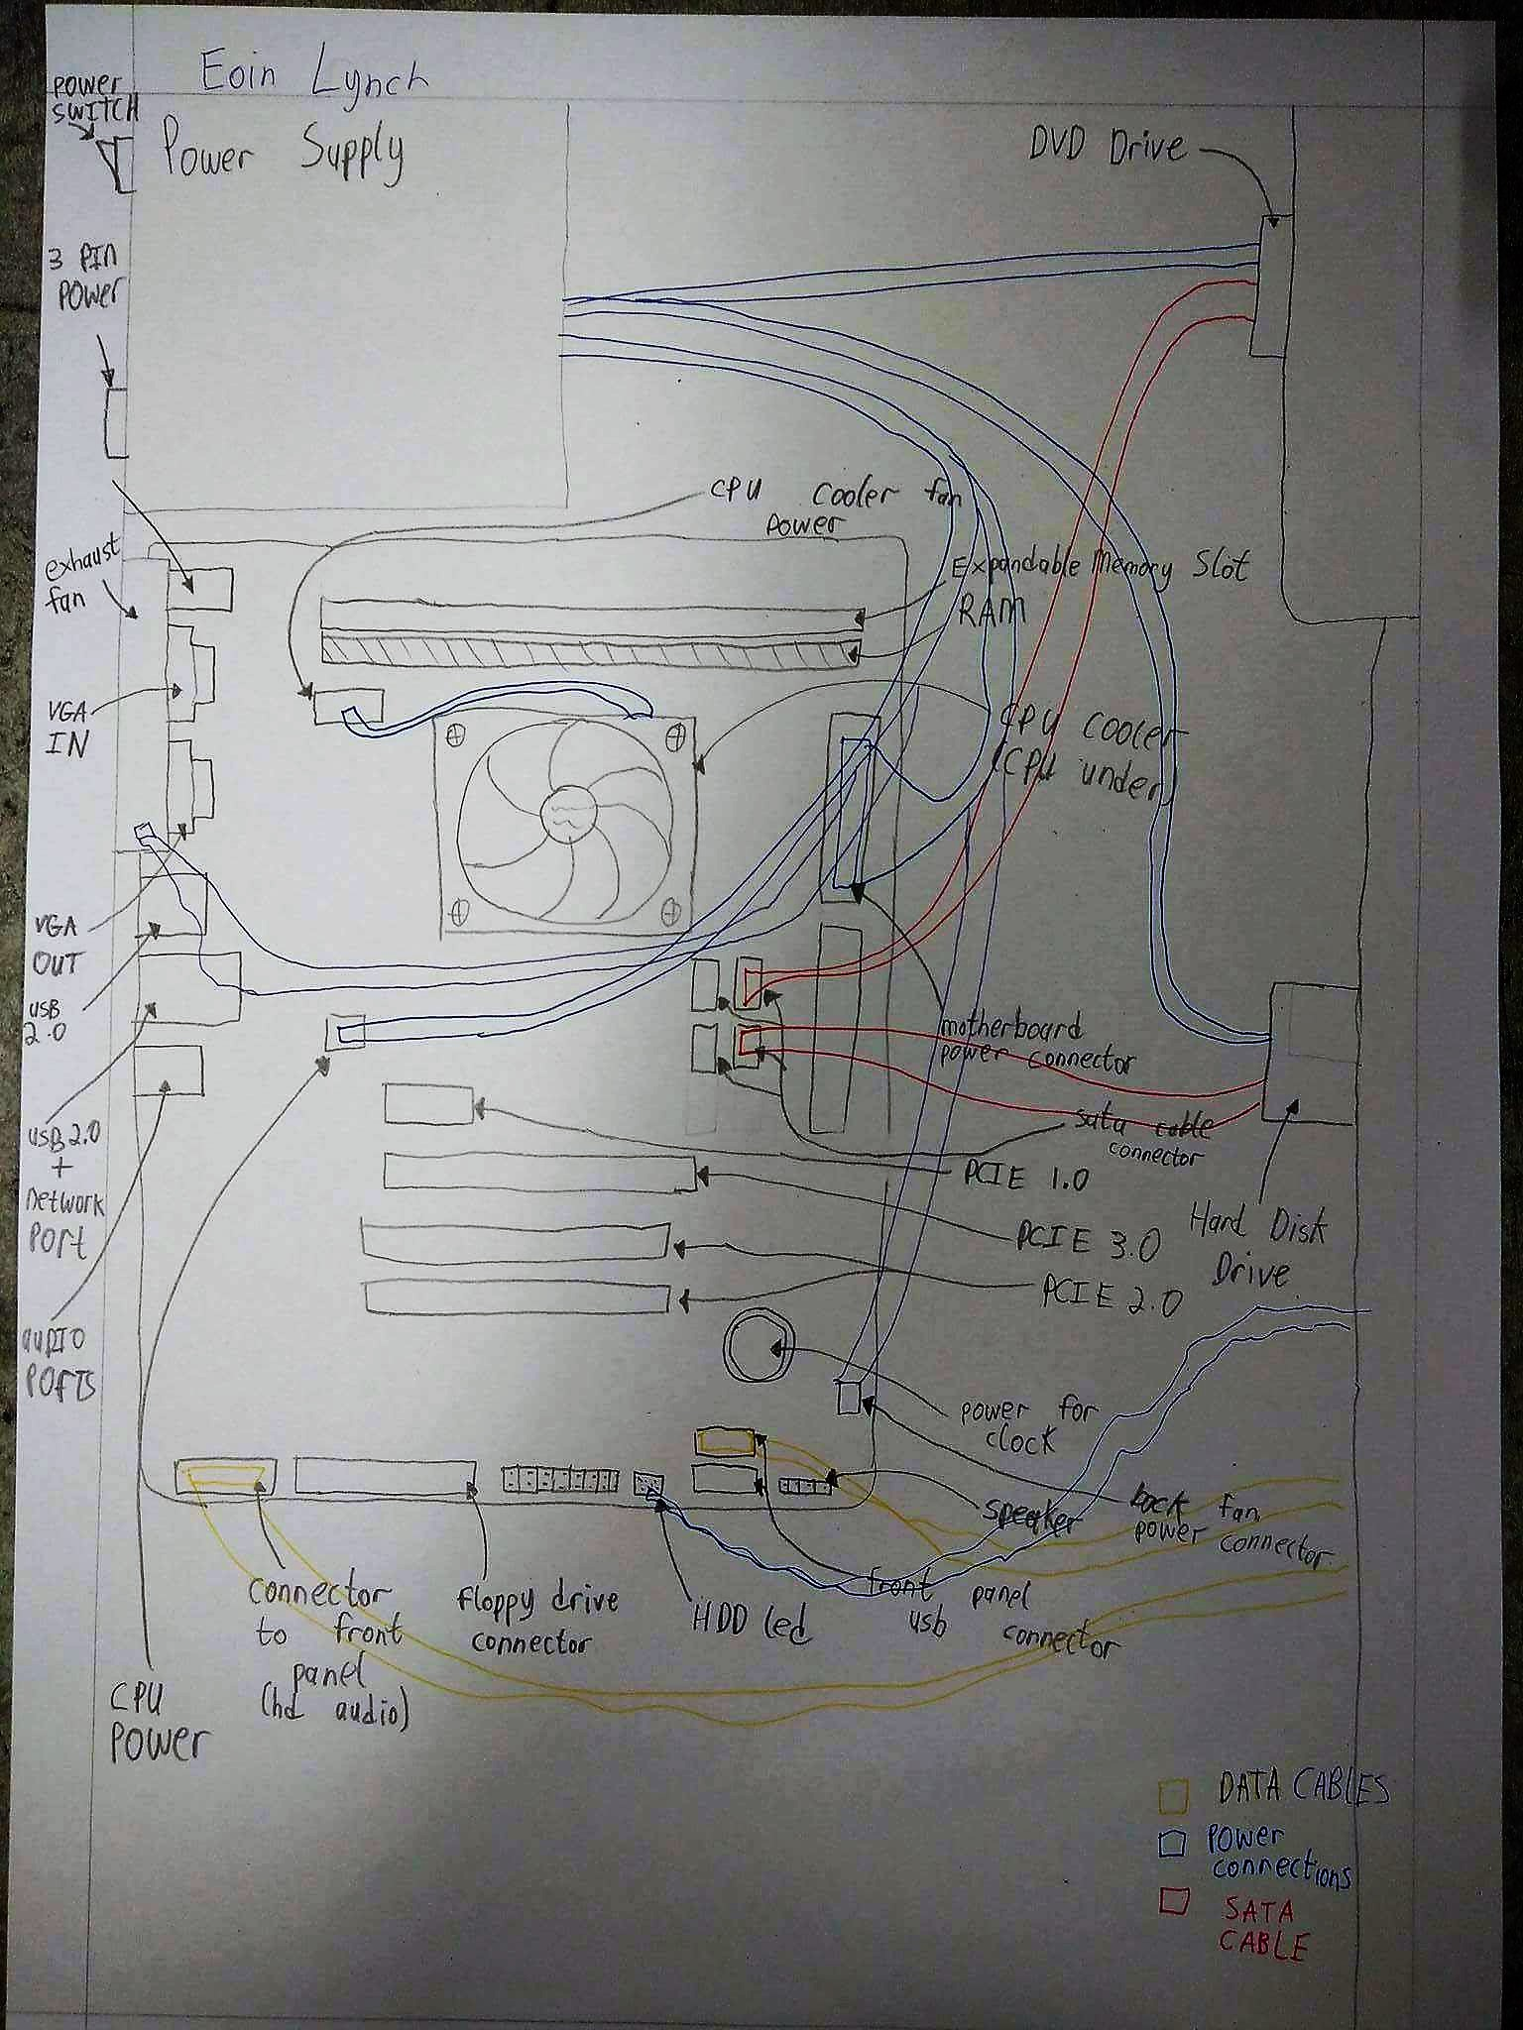**Appendix D: Sketch of PC**



**References**

* Khan, J. (2013) *Five generations of computers*. Available at: http://www.byte-notes.com/five-generations-computers (Accessed: 6 December 2016).
* *Computing* (2016) in *Wikipedia*. Available at: https://en.wikipedia.org/wiki/Computing (Accessed: 6 December 2016).
* Rouse, M. (2006) *What is microprocessor (logic chip)? - definition from WhatIs.Com*. Available at: http://whatis.techtarget.com/definition/microprocessor-logic-chip (Accessed: 6 December 2016).
* Rouse, M. (2015) *What is motherboard? - definition from WhatIs.Com*. Available at: http://whatis.techtarget.com/definition/motherboard (Accessed: 6 December 2016).
* Rouse, M. (2014) *What is hard disk? - definition from WhatIs.Com*. Available at: http://searchstorage.techtarget.com/definition/hard-disk (Accessed: 6 December 2016).
* Fisher, T. (2016) *What is a power supply unit?* Available at: https://www.lifewire.com/power-supply-unit-2618158 (Accessed: 6 December 2016).
* Rouse, M. (2011) *What is electrostatic discharge (ESD)? - definition from WhatIs.Com*. Available at: http://whatis.techtarget.com/definition/electrostatic-discharge-ESD (Accessed: 6 December 2016).